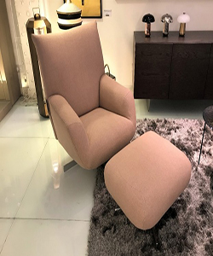

Arm chair

112.67

Availability: In stock

Description

Elegant, versatile and deliriously comfortable, the Chiara Armchair by the luxury brand Edra is the perfect place for moments of complete relaxation. Armchair and footstool with inner frame made of tubular steel and profiles. Cover is dusty pink fabric. Base with four-spoke profiles and steel turned parts finished in brushed nickel polished chrome and enables pivoting system.